Level 1 Practice Programs
- Write a program to check if a number is divisible by 5
I/P => number
O/P => Is the number ___ divisible by 5? ___

import java.util.Scanner;
public class Test {
public static void main(String[] args) {
Scanner input = new Scanner(System.in);
System.out.print("Enter a number: ");
int number = input.nextInt();
if (number % 5 == 0) {
System.out.println("Is the number " + number + " divisible by 5? Yes");
} else {
System.out.println("Is the number " + number + " divisible by 5? No");
}
input.close();
}
}

- Write a program to check if the first is the smallest of the 3 numbers.
I/P => number1, number2, number3
O/P => Is the first number the smallest? ____

import java.util.Scanner;
public class Test {
public static void main(String[] args) {
Scanner input = new Scanner(System.in);
System.out.print("Enter first number: ");
int number1 = input.nextInt();
System.out.print("Enter second number: ");
int number2 = input.nextInt();
System.out.print("Enter third number: ");
int number3 = input.nextInt();
if (number1 < number2 && number1 < number3) {
System.out.println("Is the first number the smallest? Yes");
} else {
System.out.println("Is the first number the smallest? No");
}
input.close();
}
}

- Write a program to check if the first, second, or third number is the largest of the three.
I/P => number1, number2, number3
O/P =>
Is the first number the largest? ____
Is the second number the largest? ___
Is the third number the largest? ___

import java.util.Scanner;
public class Test {
public static void main(String[] args) {
Scanner input = new Scanner(System.in);
System.out.print("Enter first number: ");
int number1 = input.nextInt();
System.out.print("Enter second number: ");
int number2 = input.nextInt();
System.out.print("Enter third number: ");
int number3 = input.nextInt();
System.out.println("Is the first number the largest? " + (number1 > number2 && number1 > number3));
System.out.println("Is the second number the largest? " + (number2 > number1 && number2 > number3));
System.out.println("Is the third number the largest? " + (number3 > number1 && number3 > number2));
input.close();
}
}

Level 2 Practice Programs
- Create a program to print odd and even numbers between 1 to the number entered by the user.
Hint =>
- Get an integer input from the user, assign to a variable number and check for Natural Number
- Using a for loop, iterate from 1 to the number
- In each iteration of the loop, print the number is odd or even number
import java.util.Scanner;
public class Main {
public static void main(String[] args) {
Scanner input = new Scanner(System.in);
System.out.print("Enter a number: ");
int number = input.nextInt();
if (number <= 0) {
System.out.println("Please enter a natural number.");
} else {
for (int i = 1; i <= number; i++) {
if (i % 2 == 0) {
System.out.println(i + " is Even");
} else {
System.out.println(i + " is Odd");
}
}
}
input.close();
}
}

2. Create a program to find the bonuses of employees based on their years of service.
Hint =>
- Zara decided to give a bonus of 5% to employees whose year of service is more than 5 years.
- Take salary and year of service in the year as input.
- Print the bonus amount.
import java.util.Scanner;
public class Main {
public static void main(String[] args) {
Scanner sc = new Scanner(System.in);
System.out.print("Enter employee salary: ");
double salary = sc.nextDouble();
System.out.print("Enter years of service: ");
int years = sc.nextInt();
double bonus = 0;
if (years > 5) {
bonus = salary * 0.05;
}
System.out.println("Bonus amount: " + bonus);
sc.close();
}
}

Level 3 Practice Programs
7.Create a program to find the BMI of a person
Hint =>
- Take user input in double for the weight (in kg) of the person and height (in cm) for the person and store it in the corresponding variable.
- Use the formula BMI = weight / (height * height). Note: unit is kg/m^2. For this convert cm to meter
- Use the table to determine the weight status of the person
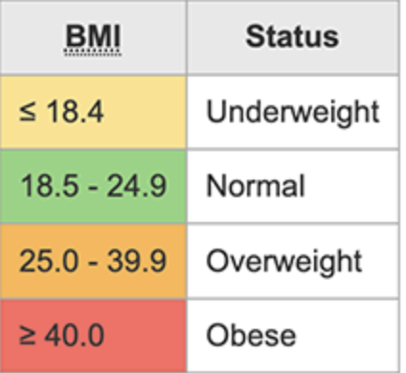

import java.util.Scanner;

public class Main {
public static void main(String[] args) {
Scanner sc = new Scanner(System.in);

System.out.print("Enter weight in kg: ");
double weight = sc.nextDouble();

System.out.print("Enter height in cm: ");
double heightCm = sc.nextDouble();

double heightM = heightCm / 100;
double bmi = weight / (heightM * heightM);

System.out.println("BMI = " + bmi);

if (bmi <= 18.4) {
System.out.println("Weight Status: Underweight");
}
else if (bmi <= 24.9) {
System.out.println("Weight Status: Normal");
}
else if (bmi <= 39.9) {
System.out.println("Weight Status: Overweight");
}
else {
System.out.println("Weight Status: Obese");
}

sc.close();
}
}

